Click here, type the title of your paper, Capitalize first letter
First Author ª, Second Author ^{b}, Third Author ^{a, b}
ª First affiliation, Address, City and Postcode, Country
^{b} Second affiliation, Address, City and Postcode, Country

Abstract
Click here and insert your abstract text.

Keywords: Type your keywords here, separated by semicolons ;

- Main text
(10 pt.) Here introduce the paper, and put a nomenclature if necessary. The paragraphs continue from here and are only separated by headings, subheadings, images and formulae. The section headings are arranged by numbers, bold and 11 pt. Here follows further instructions for authors.
  - Structure
Figures and tables should be embedded and not supplied separately. Please make sure that you use as much as possible normal fonts in your documents. Special fonts, such as fonts used in the Far East (Japanese, Chinese, Korean, etc.) may cause problems during processing. To avoid unnecessary errors you are strongly advised to use the ‘spellchecker’ function of MS Word. Follow this order when typing manuscripts: Title, Authors, Affiliations, Abstract, Keywords, Main text (including figures and tables), Acknowledgements, and References. Collate acknowledgements in a separate section at the end of the article and do not include them on the title page, as a footnote to the title or otherwise.
Bulleted lists may be included and should look like this:
- First point
- Second point
- And so on
Please do not alter the formatting and style layouts which have been set up in this template document. As indicated in the template, papers should be prepared in single column format suitable for direct printing onto A4 paper (192mm x 262 mm).
  - Tables, Figures and Equations
Figure and table captions should be 9-point Times New Roman boldface. Initially capitalize only the first word of each figure caption and table title. Figures and tables must be numbered separately. Below is an example which authors may find useful (Table 1. and Figure 1.).
Table 1. An example of a table
An example of a column heading | Column A (t) | Column B (T)
And an entry | 1 | 2
And another entry | 3 | 4
And another entry | 5 | 6
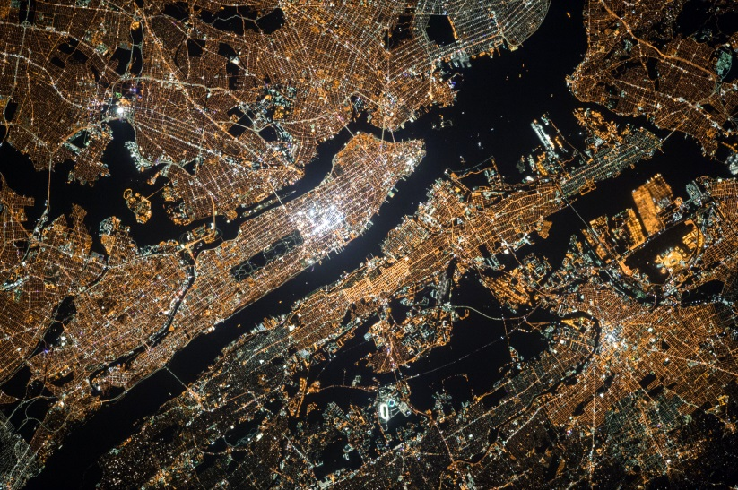
Figure 1. An example of a figure
Mathematical equations should be laid out wherever possible using an equation editor and be numbered consecutively as in this example (using the style Equation 10pt):
$$A=B+C$$ | (1)
  - Section Headings
Section headings should be left justified, with the first letter capitalized and numbered consecutively, starting with the Introduction. Sub-section headings should be in capital and lower-case italic letters, numbered 1.1, 1.2, etc, and left justified, with second and subsequent lines indented.
  - General Guidelines for the Preparation of Your Text
Avoid hyphenation at the end of a line. Symbols denoting vectors and matrices should be indicated in bold type. Scalar variable names should normally be expressed using italics. Weights and measures should be expressed in SI units.
  - Footnotes
Footnotes should be avoided if possible. Necessary footnotes should be denoted in the text by consecutive superscript letters. The footnotes should be typed single spaced, and in smaller type size (8pt), at the foot of the page in which they are mentioned, and separated from the main text by a short line extending at the foot of the column.
- Declarations
  - Author Contributions
The following statements should be used:
Conceptualization, X.X. and Y.Y.; methodology, X.X.; software, X.X.; validation, X.X., Y.Y. and Z.Z.; formal analysis, X.X.; investigation, X.X.; resources, X.X.; data curation, X.X.; writing—original draft preparation, X.X.; writing—review and editing, X.X.; visualization, X.X.; supervision, X.X.; project administration, X.X.; funding acquisition, Y.Y. All authors have read and agreed to the published version of the manuscript.
  - Data Availability Statement
Below are suggested Data Availability Statements (Please select one of them).
- Data available in a publicly accessible repository: The data presented in this study are openly available in [repository name e.g., FigShare] at [doi], reference number [reference number].
- Data available in a publicly accessible repository that does not issue DOIs: Publicly available datasets were analyzed in this study. This data can be found here: [link/accession number].
- Data available on request due to restrictions eg privacy or ethical: The data presented in this study are available on request from the corresponding author. The data are not publicly available due to [insert reason here].
- 3rd Party Data: Restrictions apply to the availability of these data. Data was obtained from [third party] and are available [from the authors/at URL] with the permission of [third party].
- Data sharing not applicable: No new data were created or analyzed in this study. Data sharing is not applicable to this article.
- Data is contained within the article or supplementary material: The data presented in this study are available in [insert article or supplementary material here].
  - Funding
Corresponding Authors are responsible for identifying and declaring all funding sources received for the research submitted to the journal. During submission, Corresponding Authors will also be asked to provide the Funder, Award Number and Grant Recipient. If there are no funders to be identified the corresponding author must state "Funding information is not available." Funding information will be entered during the submission stage and will be included in the final publication.
The author(s) received no financial support for the research, authorship, and/or publication of this article.
  - Acknowledgements
Acknowledgments are a place to recognize any contributions made to the paper that do not meet the criteria for authorship. This may include technical support, gifts received, or organizational assistance. There are few restrictions on what should be included, with the primary exception that anyone who meets the criteria for authors must be included as an author and not only acknowledged. Personal acknowledgements (e.g., of family members) are acceptable. This section should be kept relatively short, typically up to 100 words.
  - Declaration of Competing Interest
The author declares that there is no conflict of interests regarding the publication of this manuscript. In addition, the ethical issues, including plagiarism, informed consent, misconduct, data fabrication and/or falsification, double publication and/or submission, and redundancies have been completely observed by the authors
- References
List and number all bibliographical references in 9-point Times New Roman, single-spaced with 9-point interlining spacing, at the end of your paper. When referenced in the text, enclose the citation number in square brackets, for example [1]. Where appropriate, include the name(s) of editors of referenced books.
- Authors should use the following link to cite the references:
https://search.crossref.org/
- If the metadata was not exist in the “Crossref” database, authors should use “Google Scholar” to cite the references.
Example Journal Article (APA)
[1] Pan, X., Pan, X., Song, M., Ai, B., & Ming, Y. (2020). Blockchain technology and enterprise operational capabilities: An empirical test. International Journal of Information Management, 52, 101946. doi:10.1016/j.ijinfomgt.2019.05.002.
Example Book
[2] Writer, B. (2019). Lithium-Ion Batteries. Springer. doi:10.1007/978-3-030-16800-1
Example Conference Proceedings
[3] Katz, I., Gabayan, K. & Aghajan, H. (2007). A multi-touch surface using multiple cameras. In J. Blanc-Talon, W. Philips, D. Popescu & P. Scheunders (Red.), Lecture notes in Computer Science: Vol 4678. Advanced concepts for Intelligent Vision Systems (pp. 97-108). Berlin, Germany: Springer-Verlag. https://doi.org/10.1007/978-3-540-74607-2_9.
Note: Do not use the phrases "et al." and "ibid." in the reference section. Instead, the names of all authors in a reference must be listed.

Corresponding author: author@institute.xxx. http://dx.doi.org/10. xxxxx/HEF-xxxxxx This is an open access article under the CC-BY license (https://creativecommons.org/licenses/by/4.0/). © Authors retain all copyrights.

